**Methods**

This study utilized data from the second wave of the National Survey for Midlife in the United States (MIDUS 2; Ryff et al., 2004 – 2006). The MIDUS 2 study included a combination of phone interviews and mailed questionnaires across the United States to gain a nationally representative sample of English speaking middle aged adults aged 25 to 74 years of age. Data collection for the MIDUS 2 project began in 2002 and the data collection was completed in 2009. The overall sample size within the MIDUS 2 project is 4,963 participants.

**Sample**

From the MIDUS 2 sample, only participants with all demographic variables and responses to the measures used in the study were available were used in this sample of the study. Including participants based on these characteristics, the sample size was reduced to 3,701 participants. Respondents self-reported demographic information from the MIDUS 2 questionnaire. The sample population had an average age of the sample was 55.59 (*SD* = 12.14). *Table 1* shows the demographic characteristics of the sample for sexual orientation, race, and sex.

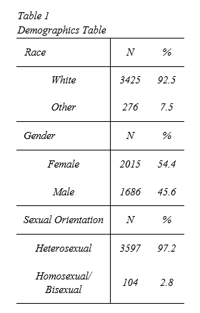

**Measures**

*Well-being Outcome Measures*

To understand the outcome of psychological and social well-being, two measures were incorporated into this study. The MIDUS 1 version of the psychological well being was used for purposes of this study and consists of six subscales. Each subscale is described in *Table 2*.

*Table 2: Psychological Well-Being Scale Descriptions*

|  |  |
| --- | --- |
| **Scale Variable Name** | **Description** |
| Autonomy | Degree to which respondent actualizes autonomy |
| Environmental Mastery | How in control of one’s environment/circumstances one feels |
| Personal Growth | How important personal is growth to respondent |
| Positive Relations with Others | Quality of relationships with other people |
| Purpose in Life | Degree to which respondent feels their life has purpose |
| Self-Acceptance | Degree to which respondent accepts their self |

Additionally, the other social well-being was assessed using the Social Well-Being scale as part of the MIDUS 2 study. Similar to the Psychological Well-Being scale, this scale consists of 5 sub scales. The subscales and descriptions are outlined in *Table 3*.

*Table 3: Social Well-Being Scale Descriptions*

|  |  |
| --- | --- |
| **Scale Variable Name** | **Description** |
| Social Coherence | How intelligible respondent’s social world appears to them |
| Social Integration | How integrated respondent feels in their community |
| Acceptance of Others | Measures positive assessment of others |
| Social Contribution | Degree to which respondent feels they contribute to their community |
| Social Actualization | Degree to which respondent feel social progress is being made |

The Psychological and Social Well-being were scored identically. Each variable is comprised of three items scored using a 7-point Likert-type scale, with scores ranging from 1 (strongly agree) to 7 (strongly disagree).  Variables are coded so that higher scores on these measures represent greater well-being (Brim et al., 2009). We then summed the summed the scale scores together to create a composite score of Psychological Well-Being. Therefore, the Psychological Well-Being scores ranged from 18, indicating the lowest state of psychological well-being to 126, indicating the highest state of psychological well-being. The Social Well-Being scores ranged from 15, indicating the lowest state of social well-being to 105, indicating the highest state of social well-being.

*Lifetime Discrimination*

Lifetime Discrimination was measured Using William et al. (1997) perceived discrimination scale which was distributed as part of MIDUS 2 questionnaire. This measure is an eleven-item scale and is measured by the by having respondents self-report the frequency of times they experience each discrimination item. Item examples include, “You were hassled by the police” or “You were not given a promotion”. For scaling, items were constructed by taking the adding the number of “1 or higher” responses to the items. Therefore, the Perceived Lifetime Discrimination Scale ranges from 0 – 11 with higher scores representing a higher amount of perceived lifetime discrimination.

**Study Design & Analytical Procedures**

Using the MIDUS 2 dataset, a cross-sectional study design was used and assessed the relationship between sexual orientation and well-being outcomes through experiences of lifetime discrimination. Therefore, the goal of this project is to obtain the effects of the indirect effect from sexual orientation through lifetime discrimination (*a* path), to our two well-being outcome measures (*b* path). Additionally, the residualized effect of sexual orientations effect on the well-being outcomes (*c`* path) will also be assessed. Two mediation models were assessed to asses this relationship (Shown in *figure 1*). All analyses performed in in this study were performed using R version 3.4.4 (R Core Team, 2018).

*Figure 1: Proposed mediated pathways from sexual orientation to psychological well-being and social well-being outcomes. Both models also controlled for race and gender.*

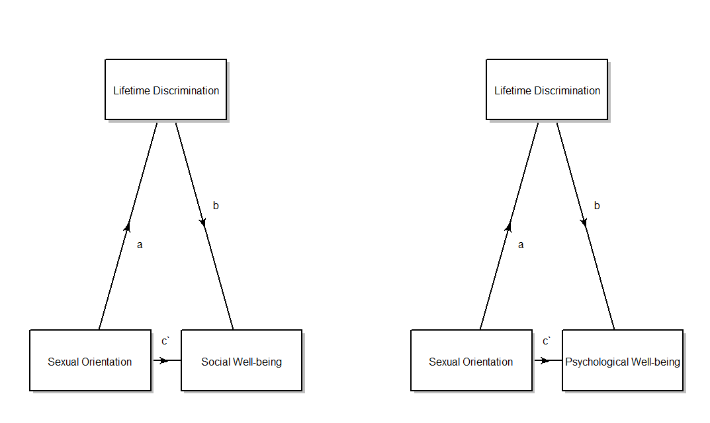

**Model 2**

**Model 1**

**Results**

*Social Well-Being*

A linear regression model was first assessed to assess the effects of the main predictor, sexual orientation status, on social well-being scores. After controlling for race and gender, no significant effect of sexual orientation on social well-being was detected (b = -1.90, p = 0.144). However, a significant effect was found between being white and better perceived social well-being scores, with white individuals experiencing better social well-being than other races (b = 2.77, p < 0.01). Thus indicating the being of white ethnicity is associated with better social well-being outcomes after controlling for sexual orientation and gender. The Social Well-being regression model is shown in *Table 4*. Because sexual orientation status did not significantly predict social well-being scores, this study did not proceed to assess the mediation of lifetime discrimination on the relationship between sexual orientation status and social well-being.

Table 4

*Regression results using Social Well-Being as the criterion*

|  |  |  |  |
| --- | --- | --- | --- |
| Predictor | *b* | *b*  95% CI  [LL, UL] | *r* |
| (Intercept) | 61.97** | [60.38, 63.55] |  |
| Sexual Orientation  (LGB =1) | -1.90 | [-4.44, 0.65] | -.02 |
| Race  (White = 1; Other = 0) | 2.77** | [1.17, 4.37] | .06** |
| Sex  (Male = 1) | 0.54 | [-0.30, 1.38] | .02 |

*R2*  = .004**

*Note.* A significant *b*-weight indicates the beta-weight and semi-partial correlation are also significant. *b* represents unstandardized regression weights. *r* represents the zero-order correlation. *LL* and *UL* indicate the lower and upper limits of a confidence interval, respectively.  
* indicates *p* < .05. ** indicates *p* < .01.

*Psychological Well-Being*

Another linear regression model was run to determine the relationship between sexual orientation and psychological well-being while controlling for participant race and Sex. Results for the main regression model may be found in *Table 5.*

*.*

Table 5

*Regression results using Psychological Well-Being as the criterion*

|  |  |  |  |  |
| --- | --- | --- | --- | --- |
| Predictor | *b* | *b*  95% CI  [LL, UL] | *r* | |
| (Intercept) | 228.85** | [224.61, 233.09] |  | |
| Sexual Orientation  (LGB =1) | -10.36** | [-17.17, -3.55] | -.05** | |
| Race  (White = 1; Other = 0) | 2.72 | [-1.56, 7.00] | .02 | |
| Sex  (Male = 1) | 1.20 | [-1.06, 3.46] | .02 | |
|  |  |  |  |

*R2*  = .003*

*Note.* A significant *b*-weight indicates the beta-weight and semi-partial correlation are also significant. *b* represents unstandardized regression weights. *r* represents the zero-order correlation. *LL* and *UL* indicate the lower and upper limits of a confidence interval, respectively.  
* indicates *p* < .05. ** indicates *p* < .01.

Results from the direct effect of sexual orientation to indicate a significant association between being of LGB status is associated with lower psychological well-being outcomes (b = -10.36, p < 0.01) after controlling for race and sex. This relationship that for being of LGB status is associated with a decrease of ~10 points in psychological well-being.

Next, because there was a significant association between Sexual orientation status and Psychological well-being outcomes after controlling for race and gender, the researchers assessed the effect lifetime discrimination had as a mediator between sexual orientation and psychological well-being. Understand this effect, a total of 2 additional linear regression models were performed. The first model was performed to assess the effect LGB has on perceived lifetime discrimination. Therefore, a linear regression model of perceived lifetime discrimination regressed on sexual orientation while holding race and sex constant was performed. Results for this model are shown in *Table 6*.

Table 6

*Regression results using perceived lifetime discrimination as the criterion*

|  |  |  |  |
| --- | --- | --- | --- |
| Predictor | *b* | *b*  95% CI  [LL, UL] | *r* |
| (Intercept) | 1.58** | [1.41, 1.76] |  |
| Sexual Orientation  (LGB =1) | 0.61** | [0.33, 0.89] | .07** |
| Race  (White = 1; Other = 0) | -0.75** | [-0.93, -0.57] | -.14** |
| Sex  (Male = 1) | -0.11* | [-0.20, -0.02] | -.04* |
|  |  |  |  |

*R2*  = .024**

*Note.* A significant *b*-weight indicates the beta-weight and semi-partial correlation are also significant. *b* represents unstandardized regression weights. *r* represents the zero-order correlation. *LL* and *UL* indicate the lower and upper limits of a confidence interval, respectively.  
* indicates *p* < .05. ** indicates *p* < .01.

The linear regression model showing the relationship between the main predictor (sexual orientation) and the proposed mediator (lifetime discrimination) yielded significant results. Being of LGB sexual orientation status is associated with a 0.61 increase in perceived lifetime discrimination. Additionally, being of another race (as opposed to white) or of female sex is also associated with more perceived lifetime discrimination.

The significant relationship between sexual orientation and lifetime discrimination allowed the researchers to proceed to assess the mediated effect. Therefore, the mediated path from being of LGB sexual orientation status, through the perceived lifetime discrimination to outcome score on psychological well-being was appraised through a linear regression model using sexual orientation status as the main predictor for psychological well-being while assessing the mediated effect perceived lifetime discrimination and holding constant Race and sex. Result are shown in *Table 7*.

Table 7

*Regression results using Psychological Well-Being as the criterion*

|  |  |  |  |
| --- | --- | --- | --- |
| Predictor | *b* | *b*  95% CI  [LL, UL] | *r* |
| (Intercept) | 232.34** | [227.94, 236.74] |  |
| Sexual Orientation  (LGB =1) | -9.02** | [-15.81, -2.22] | -.05** |
| Lifetime Discrimination | -2.21** | [-2.99, -1.43] | -.10** |
| Race  (White = 1; Other = 0) | 1.07 | [-3.24, 5.37] | .02 |
| Sex  (Male = 1) | 0.96 | [-1.29, 3.21] | .02 |
|  |  |  |  |
|  |  |  |  |

*R2*  = .011**

*Note.* A significant *b*-weight indicates the beta-weight and semi-partial correlation are also significant. *b* represents unstandardized regression weights. *r* represents the zero-order correlation. *LL* and *UL* indicate the lower and upper limits of a confidence interval, respectively.  
* indicates *p* < .05. ** indicates *p* < .01.

Result from *Table 7* show that even after controlling for sexual orientation, lifetime discrimination serves as a significant predictor of psychological well-being after controlling for sexual orientation, race, and sex. For every 1-unit increase on an individual’s lifetime discrimination scale, a predicted 2.21 decrease in their psychological well-being is expected to be observed.

Lastly, the indirect effect of the path leading from sexual orientation to psychological well-being, after accounting for the mediated affect of lifetime discrimination and the control variables (race and sex) was assessed. The indirect effect is calculated by obtaining the product of the beta coefficient for sexual orientation on path from the sexual orientation status to lifetime discrimination (the ‘a-path’ in *figure 1:* model 1; b = 0.61) by the beta coefficient of the beta coefficient for Lifetime Discrimination for the path leading from lifetime discrimination Psychological well-being (the ‘b-path’ in figure 1: model 1; b = -2.21). This method for calculating indirect effects was proposed by Hayes, Preacher & Meyers (2011). Therefore, the indirect effect of sexual orientation on Psychological Well-being is *-1.34*. Confidence intervals for the indirect effect were obtained using a bootstrap analysis. Bootstrap analyses obtained a 95% confidence interval of LL= -2.567, UL =-0.584. Therefore, it was concluded that the indirect effect of sexual orientation on psychological well-being was significant, after controlling for the mediated effect of Lifetime discrimination – Race and sex were also controlled for. A complete diagram of including the path coefficients is shown in *Figure 2*. Results from these regression analyses suggest that the Lifetime Discrimination is a partial mediator between Sexual orientation and Psychological well-being. Even after controlling for the mediated effects of Lifetime discrimination, being of LGB status has the tendency to lead to worse psychological well-being outcomes.

*Figure 2: Mediated pathways from sexual orientation to psychological well-being outcome. Model also controlled for race and gender.*

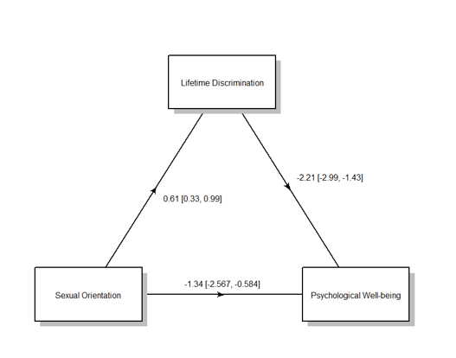

References

Hayes, A. F., Preacher, K. J., & Myers, T. A. (2011). Mediation and the estimation of indirect effects in political communication research. Sourcebook for political communication research: Methods, measures, and analytical techniques, 23, 434-465.

R Core Team (2018). R: A language and environment for statistical computing. R Foundation for Statistical Computing, Vienna, Austria. URL https://www.R-project.org/.